|  |  |  |
| --- | --- | --- |
|  | TABLE OF CONTENTS |  |
|  | Acknowledgement | 2 |
|  | Abstract | 3 |
|  | List of Tables | 4 |
|  | List of Figures | 5 |
| Chapter 1 | **Introduction** |  |
|  | 1.1 Project Profile | 6 |
| Chapter 2 | **Requirement Specification** |  |
|  | 2.1 Existing System |  |
|  | 2.2 Need For New System |  |
|  | 2.3 Time line Chart |  |
| Chapter 3 | **3.1 Introduction** |  |
|  | 3.1.1 Purpose |  |
|  | 3.1.2 Scope |  |
|  | **3.2 General Description** |  |
|  | 3.2.1 Functional Description |  |
|  | 3.2.2 User Characteristics |  |
| Chapter 4 | **Hardware & Software Specification** |  |
|  | 4.1 Hardware Requirement |  |
|  | 4.1 Hardware Requirement |  |
|  |  |  |
|  |  |  |
|  |  |  |
|  |  |  |

**ACKNOWLEDGMENT**

We would like to thank everyone who helped in our project. We have this great

opportunity to express our deep gratitude to our Mentor Mr. Tulsidas Nakrani of SPCE

MCA College, Visnagar for his timely and valuable guidance as well as for responding

faith and confidence on us throughout the duration of our project whenever needed.

Lastly it is our great pleasure to acknowledge our obligation to all those who were

directly or indirectly involve in making our partial project a successful piece of work.

Your Faithfully,

Vivek Patel.

Priya Patel.

**ABSTRACT**

it’s refers to the buying and selling of goods or services using the internet, and the transfer of money and data to execute these transactions.

**LIST OF TABLE**

|  |  |  |
| --- | --- | --- |
| Table No | Table Name | Page No |
| Table 1 | Auth_user |  |
| Table 2 | Home_contact |  |
| Table 3 | shop_category |  |
| Table 4 | shop_subcategory |  |
| Table 5 | Shop_productimages |  |
| Table 6 | Shop_product |  |
| Table 7 | Cart_UserCart |  |
| Table 8 | Order_order |  |

**LIST OF FIGURES**

|  |  |  |
| --- | --- | --- |
| Figure No | Figure Name | Page No |
| Figure 1 | Entity Relationship Diagram |  |
| Figure 2 | Use Case Diagram |  |
| Figure 3 | Class Diagram |  |
| Figure 4 | Sequence Diagram |  |
| Figure 5 | Activity Diagram |  |

1. **INTRODUCTION**

|  |  |
| --- | --- |
| 1.1 Project Profile | |
| Project Title | E-Commerce Shopping website(agwiscart.com) |
| Project Definition | it’s refers to the buying and selling of goods or services using the internet, and the transfer of money and data to execute these transactions. |
| Internal Project Guide | Prof. Tulsidas Nakrani |
| Team Size | 2 |
| Team Member | 1.patel vivek D  2. patel Priya S |
| Application Server | python 3.8(Django testing server) |
| Front End | python 3.8 |
| Using Framework | Django 3.1(python framework) |
| Back End | Mysql |
| Report Generation Tool | MS Word 2016  MS PowerPoint 2016 |
| Project Duration | 4 months |

**2.REQUIREMENT SPECIFICATION**

**2.1 Existing System:**

* Time Consuming
* Shipping Rates and Refunds/Returns Disputes
* Lack of options
* Cash-Back offers not present
* Bad customer service
* Also there are expenses for traveling from house to shop. More over the shop from where we would like to buy something may not be open 24*7. In order to
* overcome these, we have e-commerce solution, i.e. one place where we can get all required goods/products online.

**2.2 Need for New System**

* The Online Shopping System (OSS) is a web-based application. The purpose of the application is to automate and facilitate the whole process of shopping. This application fixes the limitation and problems of paper based processes. The main goal to increase the quantity of sales by making the new technology of web pages design more attractive and to search a lot of customers and company to their location. By this system we can advertise and send procure to a lot of customer by sending email.
* Reduce management costs
* Businesses aim at reducing the costs incurred for the betterment of their revenue. Automating the ecommerce business can help in reducing the management cost significantly. Moreover, the right use of digital marketing can help in reducing the cost spent on driving customers to such an extent that businesses can bring customers for free of cost.
* Developing business relations
* Providing a unique customer experience
* Increasing the number of loyal customers
* Increasing sales

**2.3 Time Line Chart**

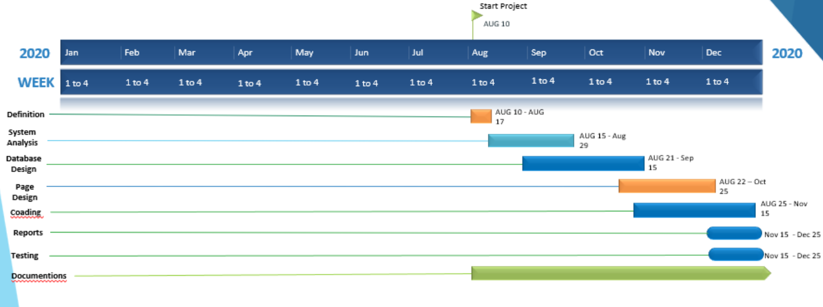

**3.FUNCTIONAL SPECIFICATION**

**3.1 Introduction**

**3.1.1. Purpose**

This website is used to the buying and selling of goods or services using the internet, and the transfer of money and data to execute these transactions,

**3.1.2. Scope**

**Admin:-**

* + Login
  + Manage products
  + Manage cart
  + Manage orders
  + View all orders
* **user:-**
  + Register
  + Login
  + Search products
  + View All products
  + Add to cart
  + Make order
  + Pay bills

**3.2 General Description**

**3.2.1. Functional Description**

* **ADMIN:-**

View, insert, update, or delete record of admin.

* **USER:-**

View, insert, update, or delete record of any product in cart.

**3.2.2. User Characteristics**

**Admin:-**

Admin is a top level person who is responsible for that site management and has keen watch on the site movements. Admin can add Product View all orders and Payment Activity.

**User:-**

Lawyer is second level person who can Search and view Products and make order. It can manage cart items

**4.HARDWARE & SOFTWARE SPECIFICATION**

**4.1 Hardware Requirement:-**

* PROCESSOR : Intel Core i3
* RAM : 4GB(recommended)
* HARD-DISK : 500GB(recommended)
* WINDOWS : WINDOWS 10

**4.2 Software Requirement:-**

* FRONT END TOOL : python 3.8
* BACK END TOOL : MySQL 5.0
* FRAMEWORK : Django 3.1
* CODE EDITOR : VS(visual studio) code editor
* OTHER TOOLS : MS Word 2016 MS PowerPoint 2016

**5. Detailed Design**

**5.1 Data Dictionary**

**1)auth user**

Table name: auth_user

Description: this is user as well as customer table .it’s a user authontication table

Primary key: id

Foreign key :

|  |  |  |  |  |  |
| --- | --- | --- | --- | --- | --- |
| SR.NO | Field Type | Data Type | Size | Constraints | Description |
| 1 | Id | Int | 11 | Primary key | User id |
| 2 | Password | Varchar | 128 | Not null | User password |
| 3 | Last_login | Datetime | 6 | Not null | Last log in date |
| 4 | Is_superuser | Tinyint | 1 | Not null | Check superuser |
| 5 | Username | Varchar | 150 | Unique key | Username use to log in |
| 6 | First_name | Varchar | 30 | Not null | User first name |
| 7 | Last_name | Varchar | 150 | Not null | User last name |
| 8 | email | Varchar | 254 | Not null | User e-mail address |
| 9 | Is_staff | Tinyint | 1 | Not null | Chack the user is staff |
| 10 | Is_active | Tinyint | 1 | Not null | Check user is active |
| 11 | Date_joined | Datetime | 6 | Not null | User added time |

**2) contact:-**

Table name: contact

Description: this is contact us table .it’s a use to store the contact us details

Primary key: cid

Foreign key :

|  |  |  |  |  |  |
| --- | --- | --- | --- | --- | --- |
| SR.NO | Field Type | Data Type | Size | Constraints | Description |
| 1 | cid | Int | 11 | Primary key | Contact id |
| 2 | fullname | Varchar | 255 | Not null | User full name |
| 3 | subject | Varchar | 50 | Not null | Subject detail |
| 4 | cemail | Varchar | 10 | Not null | User email |
| 5 | msg | Longtext | - | Not null | Message |
| 6 | timestamp | Datetime | 6 | Not null | Added time |

**3) products:-**

Table name: products

Description: this is products table .it’s a use to showing searching and fetching the products

Primary key: product_id

Foreign key :category_id, subcategory_id

|  |  |  |  |  |  |
| --- | --- | --- | --- | --- | --- |
| SR.NO | Field Type | Data Type | Size | Constraints | Description |
| 1 | product_id | Int | 11 | Primary key | It’s product id |
| 2 | title | Varchar | 50 | Not null | Product title |
| 3 | price | Int | 11 | Not null | Product price |
| 4 | sell_price | Decimal | 5.2 | *NULL* | Product sell price |
| 5 | Category_id | int | 11 | Foreign Key | Product category |
| 6 | description | Varchar | 300 | Not null | Product description |
| 7 | slug | Varchar | 50 | *NULL* | Product slug as tltle |
| 8 | pub_date | date | - | Not null | Product published date |
| 9 | active | Tinyint | 1 | Not null | Check product is available or not |
| 10 | subcategory_id | Int | 11 | Foreign Key | Product sub category |

**4) Category:-**

Table name: Category

Description: this is Category table .it’s a use to Categorised the products

Primary key: category_id

Foreign key :

|  |  |  |  |  |  |
| --- | --- | --- | --- | --- | --- |
| SR.NO | Field Type | Data Type | Size | Constraints | Description |
| 1 | category_id | int(11) | 11 | *Primary key* | Category id |
| 2 | title | varchar(128) | 128 | Not null | Category title |
| 3 | description | varchar(300) | 300 | Not null | Category description |
| 4 | slug | varchar(50) | 50 | *NULL* | Category slug |
| 5 | thumbnail | tinyint(1) | 1 | Not null | Check thumbnail |
| 6 | active | tinyint(1) | 1 | Not null | Check Category active |
| 7 | timestamp | datetime(6) | 6 | Not null | Category added time |

**5)SubCategory**

Table name: SubCategory

Description: this is SubCategory table .it’s a use to define subcategory of the products

Primary key: category_id

Foreign key :

|  |  |  |  |  |  |
| --- | --- | --- | --- | --- | --- |
| SR.NO | Field Type | Data Type | Size | Constraints | Description |
| 1 | subcategory_id | int(11) | 11 | *Primary key* | SubCategory id |
| 2 | title | varchar(128) | 128 | Not null | SubCategory title |
| 3 | description | varchar(300) | 300 | Not null | SubCategory description |
| 4 | slug | varchar(50) | 50 | *NULL* | SubCategory slug |
| 5 | thumbnail | tinyint(1) | 1 | Not null | Check thumbnail |
| 6 | active | tinyint(1) | 1 | Not null | Check SubCategory active |
| 7 | timestamp | datetime(6) | 6 | Not null | SubCategory added time |

**6) productsImages:-**

Table name: productsImages

Description: this is product images table .it’s a use to store the products images

Primary key: id

Foreign key :product_id

|  |  |  |  |  |  |
| --- | --- | --- | --- | --- | --- |
| SR.NO | Field Type | Data Type | Size | Constraints | Description |
| 1 | id | Int | 11 | Primary key | ProductsImages Id |
| 2 | Image | Varchar | 100 | Not null | Product Images url |
| 3 | Featured | Tinyint | 1 | Not null | Product fratured |
| 4 | Active | Tinyint | 1 | Not null | Check the Product is active |
| 5 | Timestamp | Datetime | 6 | Not null | Product Added time |
| 6 | product_id | Int | 11 | Foreign Key | Product id |

**7) UserCart**

Table name: UserCart

Description: this is user as well as customer table .it’s a user authentication table

Primary key: id

Foreign key : cart_id, product_id

|  |  |  |  |  |  |
| --- | --- | --- | --- | --- | --- |
| SR.NO | Field Type | Data Type | Size | Constraints | Description |
| 1 | id | Int | 11 | *Primary key* | Cart items id |
| 2 | quantity | Int | 11 | Not null | Product quantity |
| 3 | Payment_status | Tinyint | 1 | Not null | Totle products price |
| 4 | added_on | Datetime | 6 | Not null | Product Added time |
| 5 | updated | Datetime | 6 | Not null | Cart updated time |
| 6 | owner_id | Int | 11 | Foreign Key | Which user cart |
| 7 | product_id | Int | 11 | Foreign Key | Product id |

**8) order**

Table name: order

Description: this is order table .it’s a use to store order information

Primary key: id

Foreign key :

|  |  |  |  |  |  |
| --- | --- | --- | --- | --- | --- |
| SR.NO | Field Type | Data Type | Size | Constraints | Description |
| 1 | Order_id | Int | 11 | *Primary key* | order id |
| 2 | first_name | Varchar | 90 | Not null | Order Owner first name |
| 3 | last_name | Varchar | 90 | Not null | Order Owner last name |
| 4 | state | Varchar | 111 | Not null | Order Owner state |
| 5 | address | Varchar | 111 | Not null | Order Owner address |
| 6 | address2 | Varchar | 111 | Null | Order Owner address 2 |
| 7 | City | Varchar | 111 | Not null | Order Owner city |
| 8 | Zip_code | Varchar | 111 | Not null | Order Owner zip_code |
| 9 | Phone | Varchar | 111 | Not null | Order Owner contact number |
| 10 | Email | Varchar | 111 | Not null | Order Owner email |
| 11 | amount | int | 10 | Not null | Totle order amount |

**5.2 Entity Relationship Diagram**

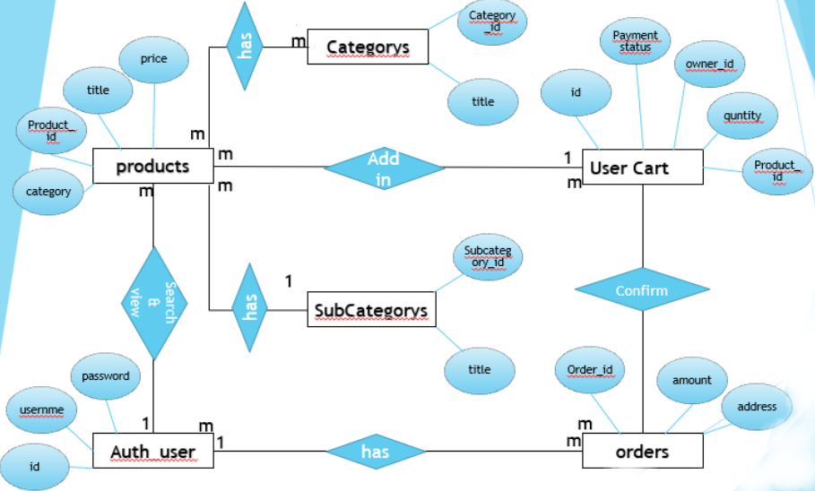

**5.3 UML Diagrams**

**5.3.1 USE CASE DIAGRAM**

**ADMIN:-**

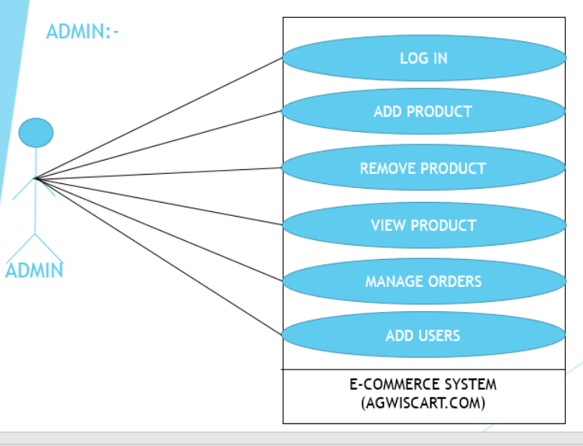

**USER(CUSTOMER):-**

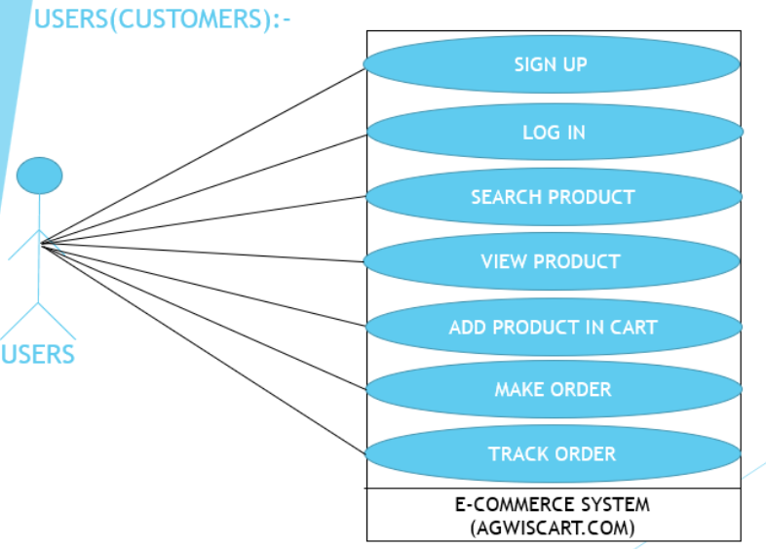

**5.3.2 CLASS DIAGRAM**

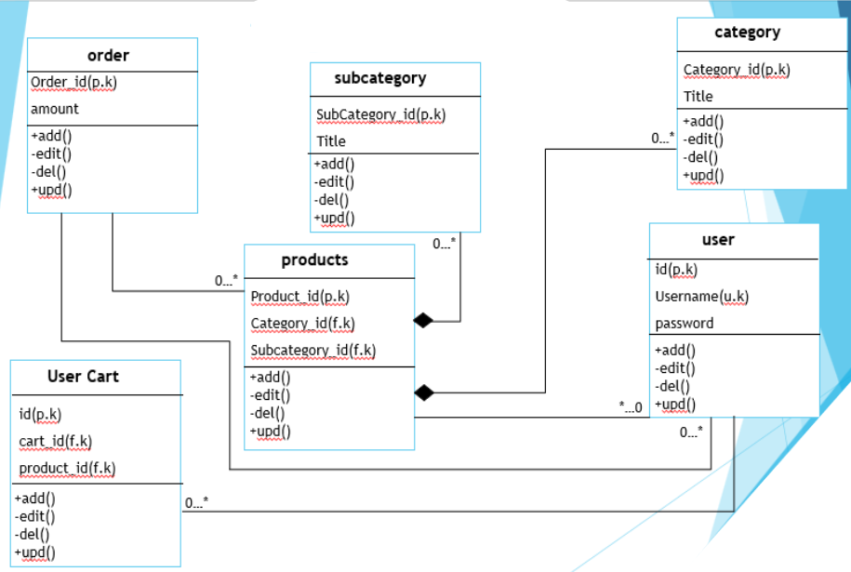

**5.3.3 SEQUENCE DIAGRAM**

**Admin:-**

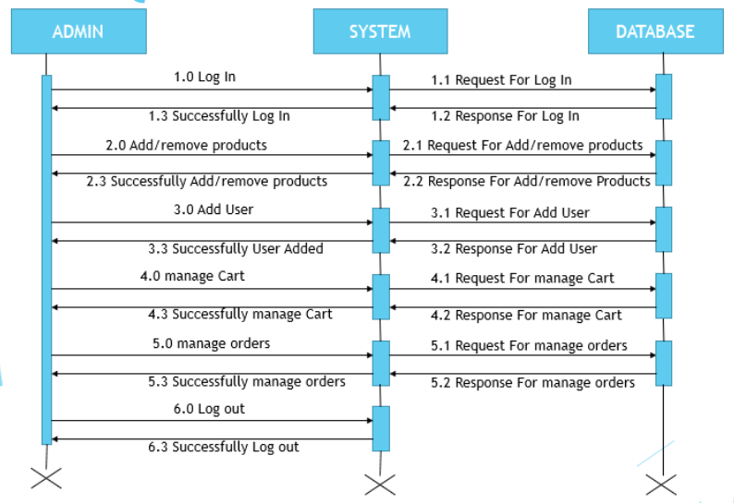

**User:-**

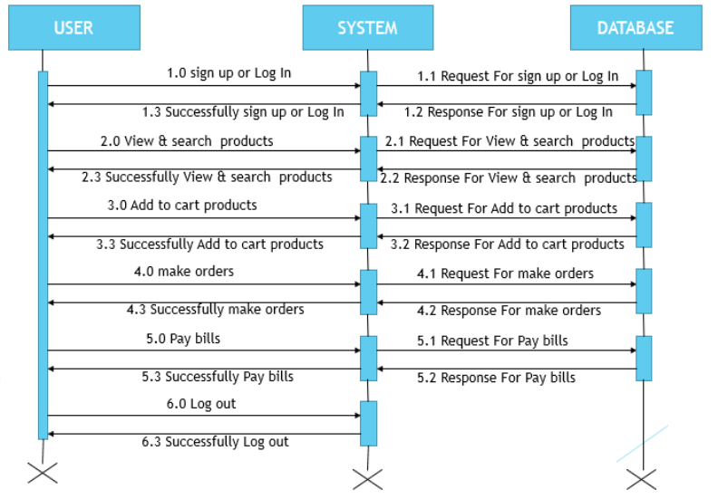

**5.3.4 ACTIVITY DIAGRAM**

**Admin :-**

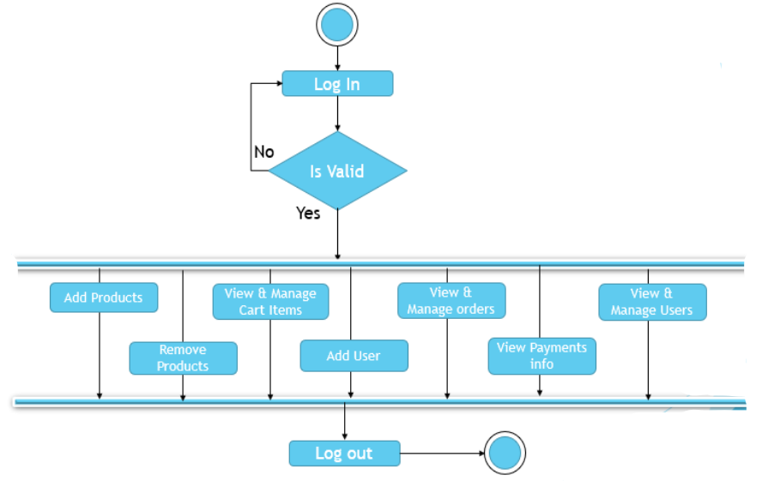

**User :-**

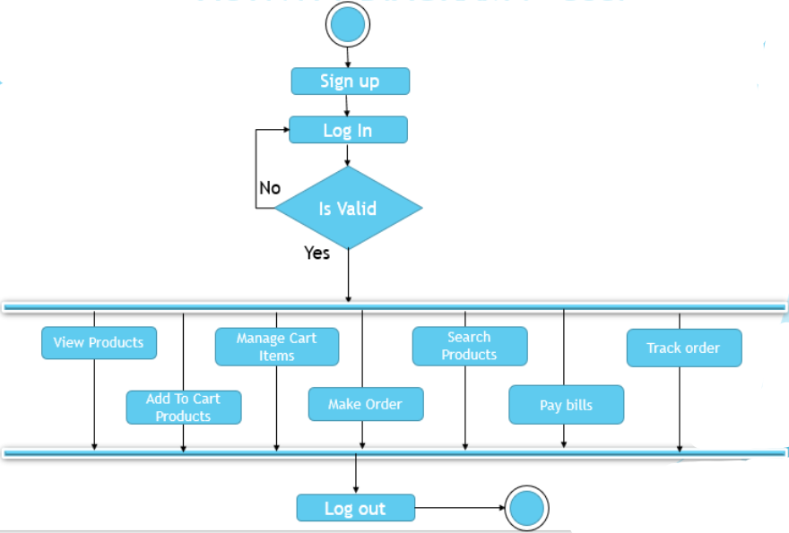

**6. Input & Output Designing**

**6.1 Admin Side Design**

**Login page:- this page is admin login page**

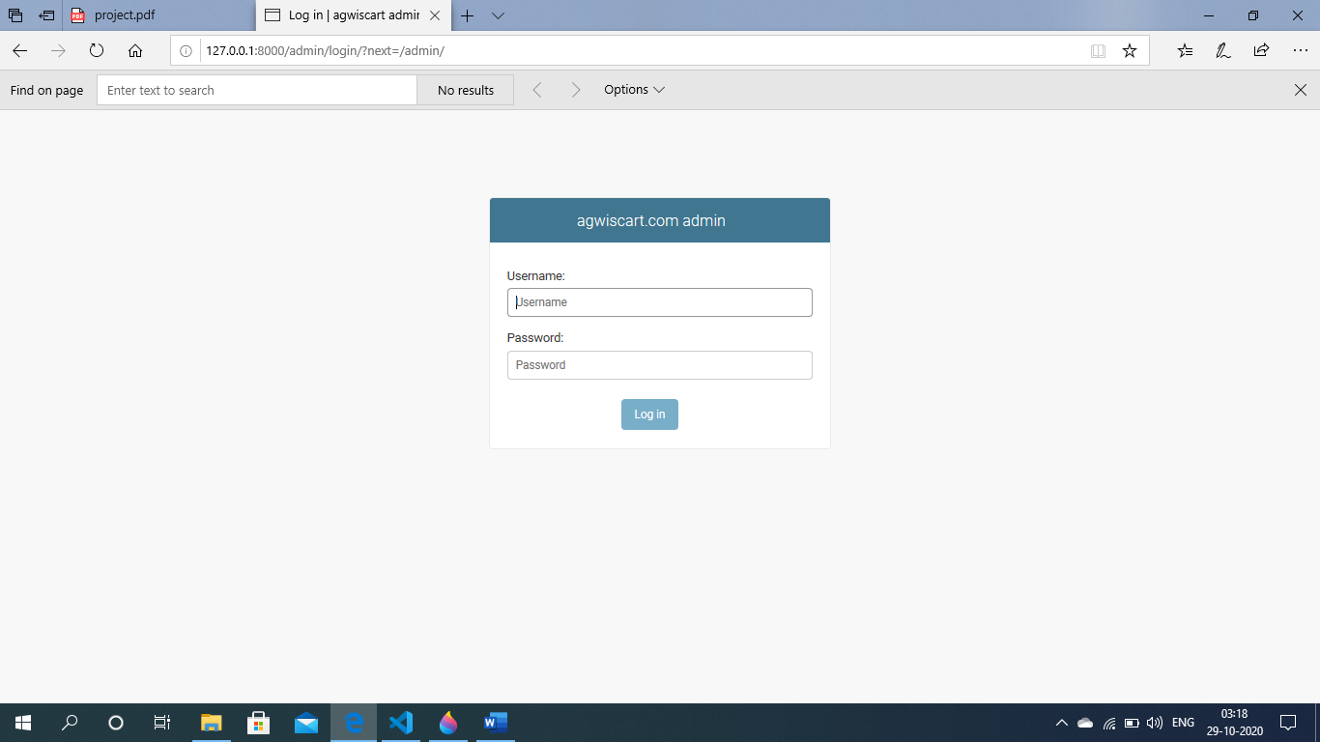

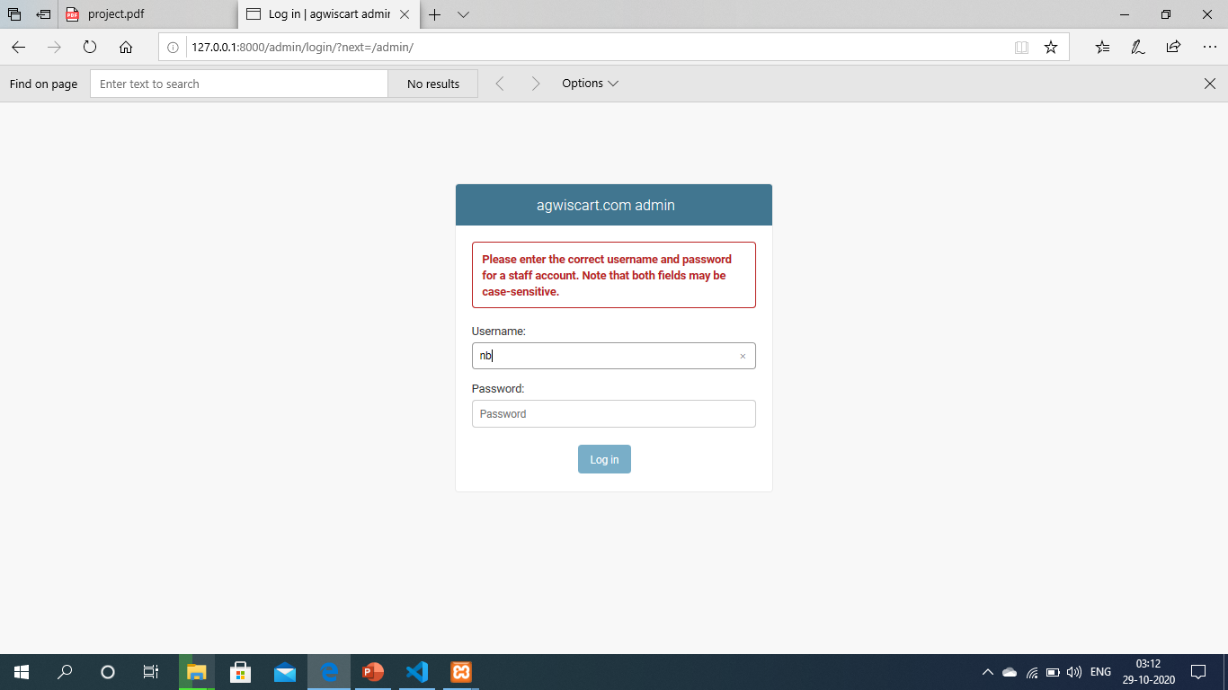

**Admin home page:-**

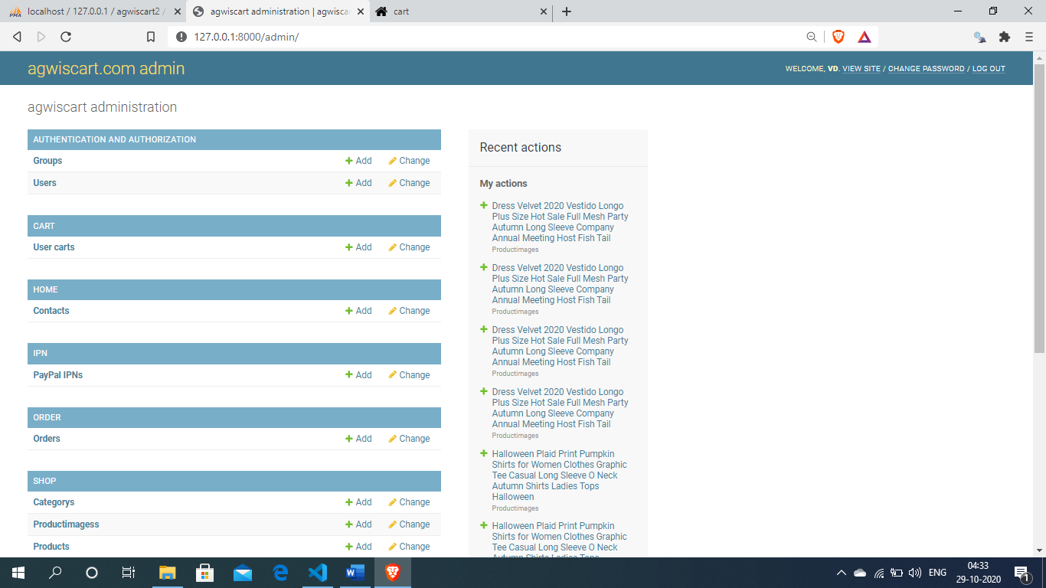

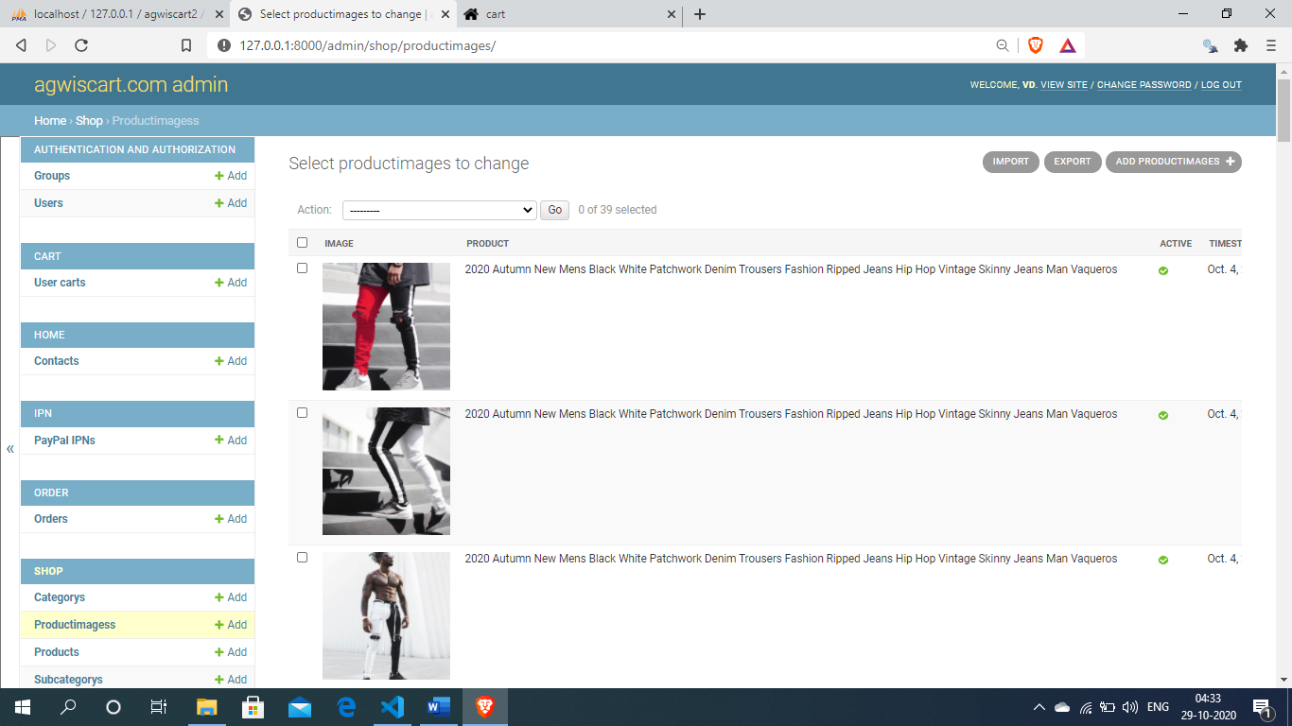

**Admin add products :-**

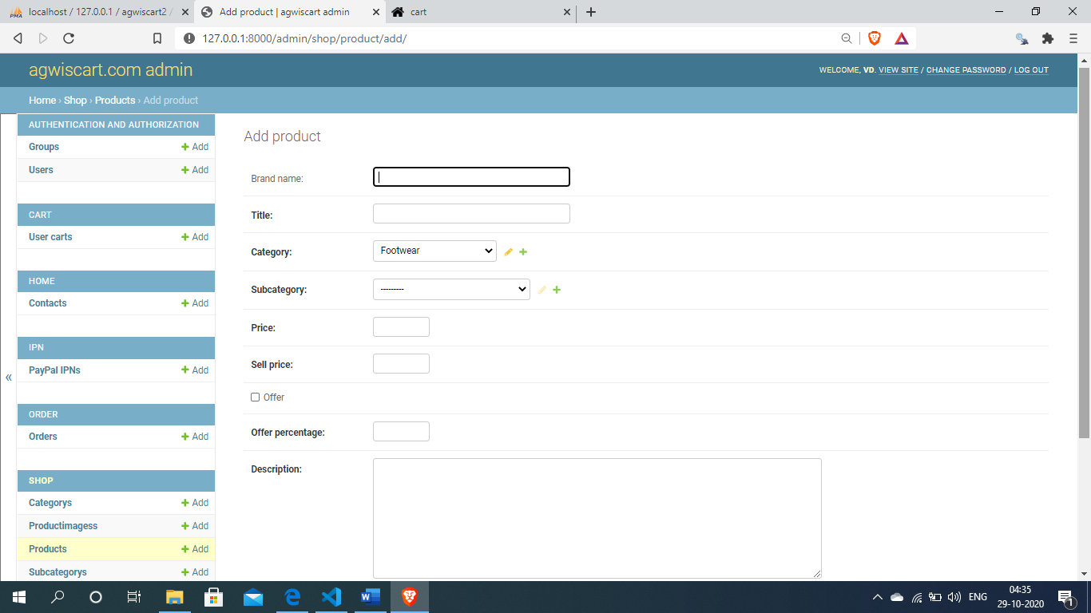

**View products :-**

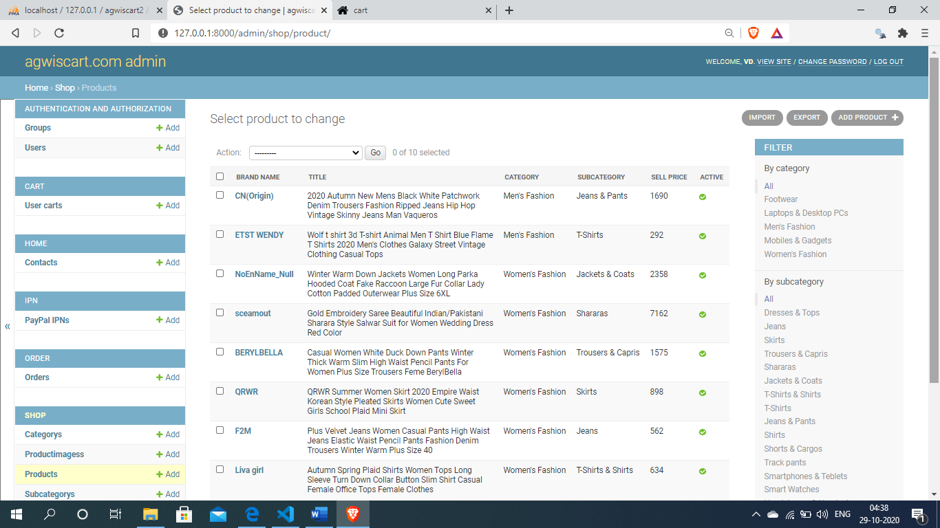

**6.2 User side design**

**User home page:-**this page is agwiscart.com home page

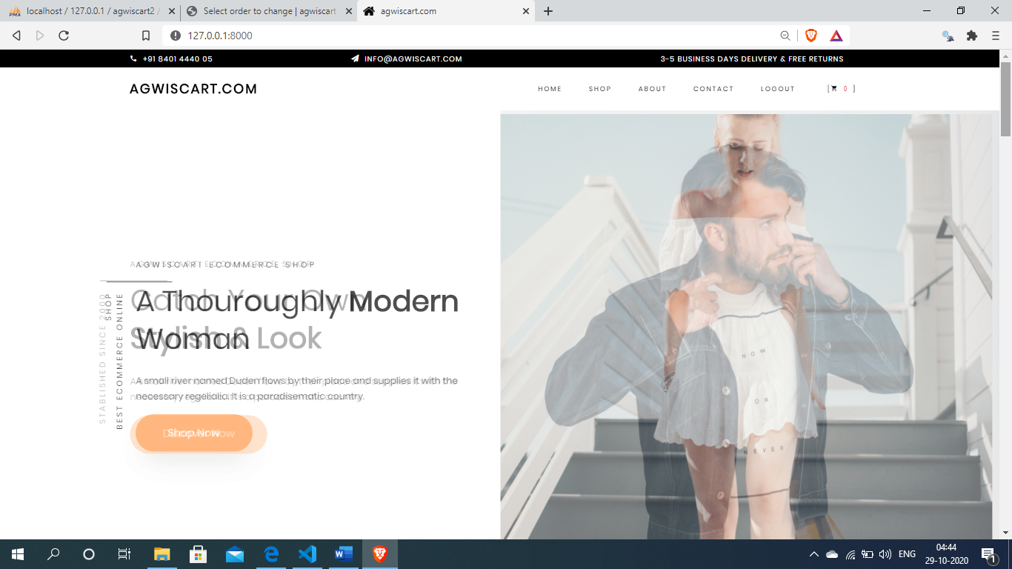

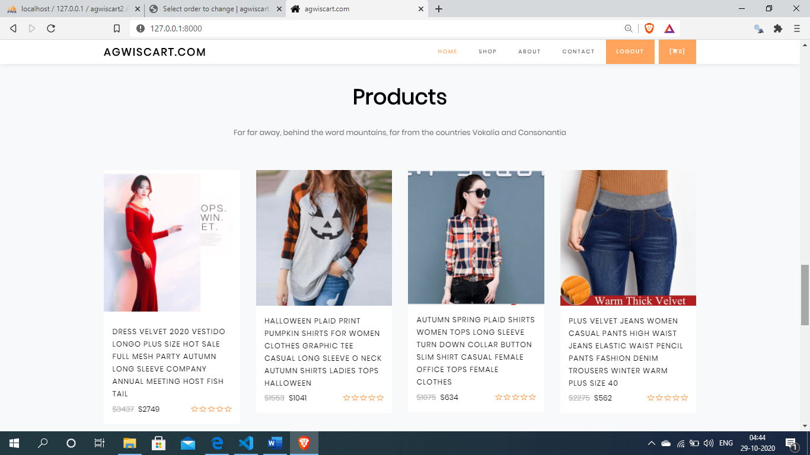

**Shop page:-**

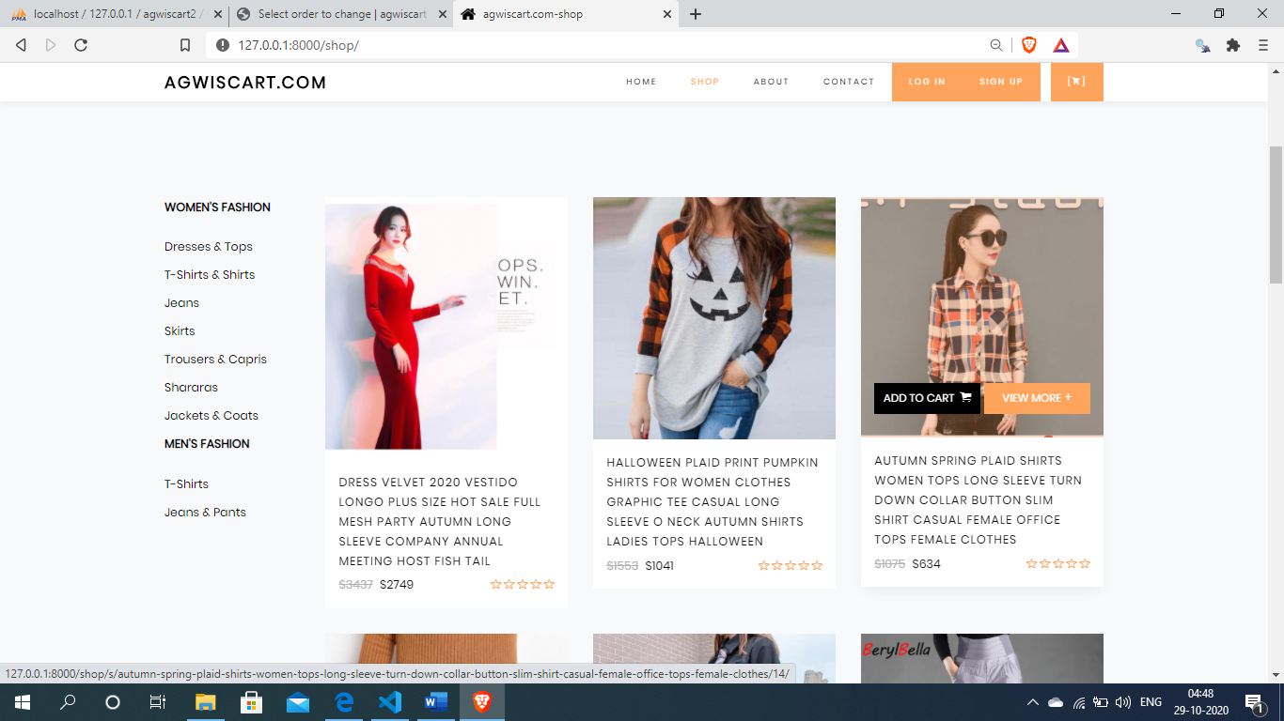

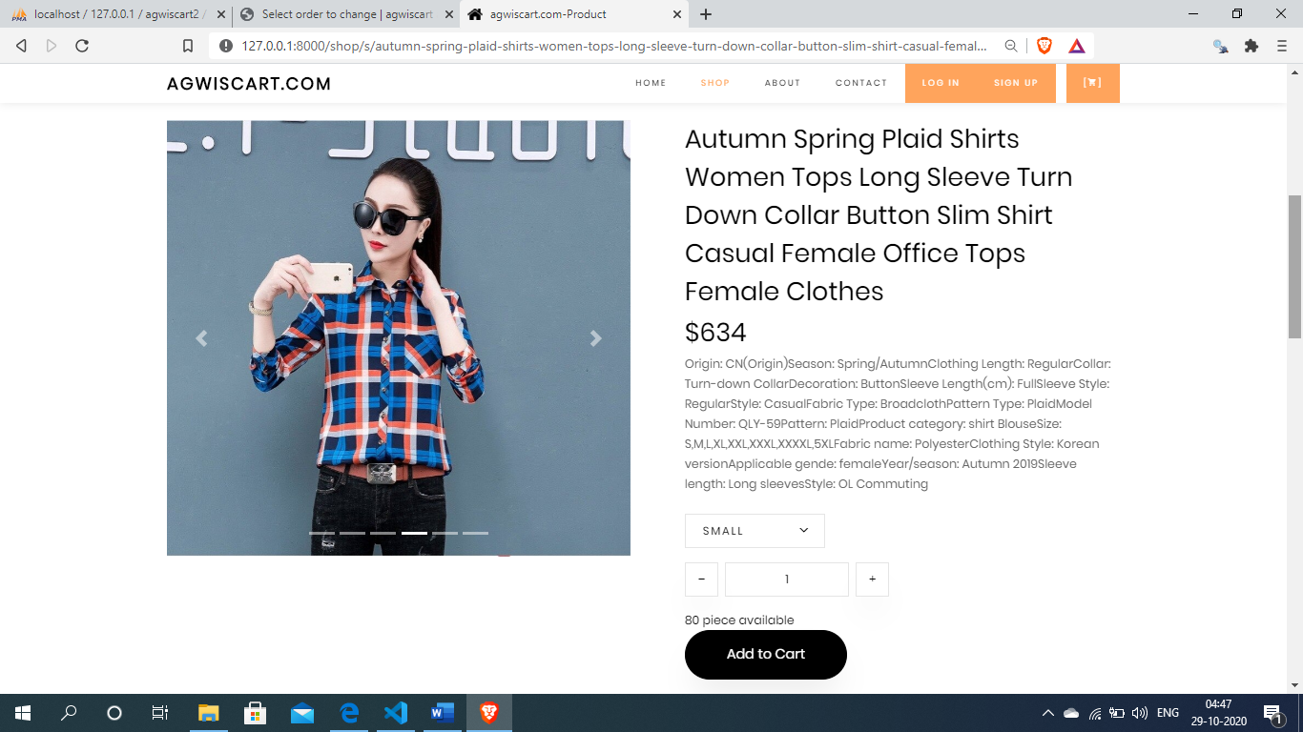

**About page :-**

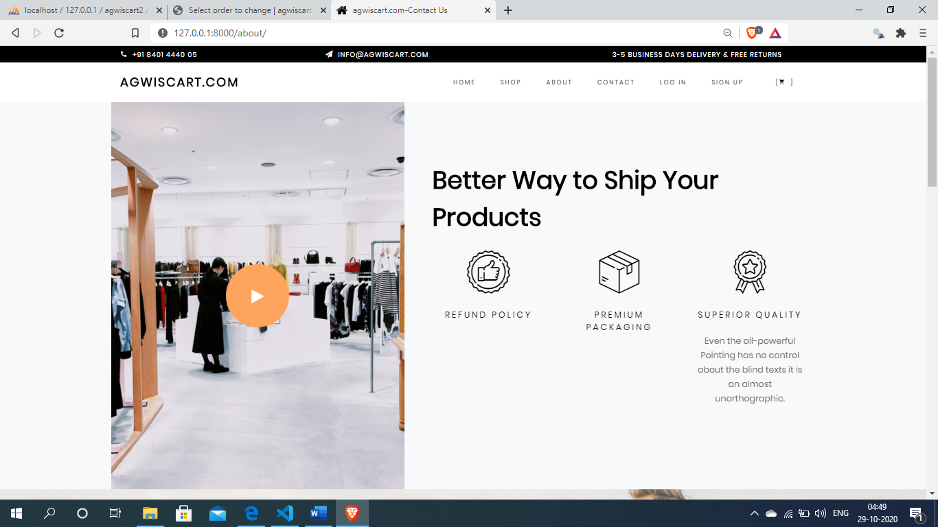

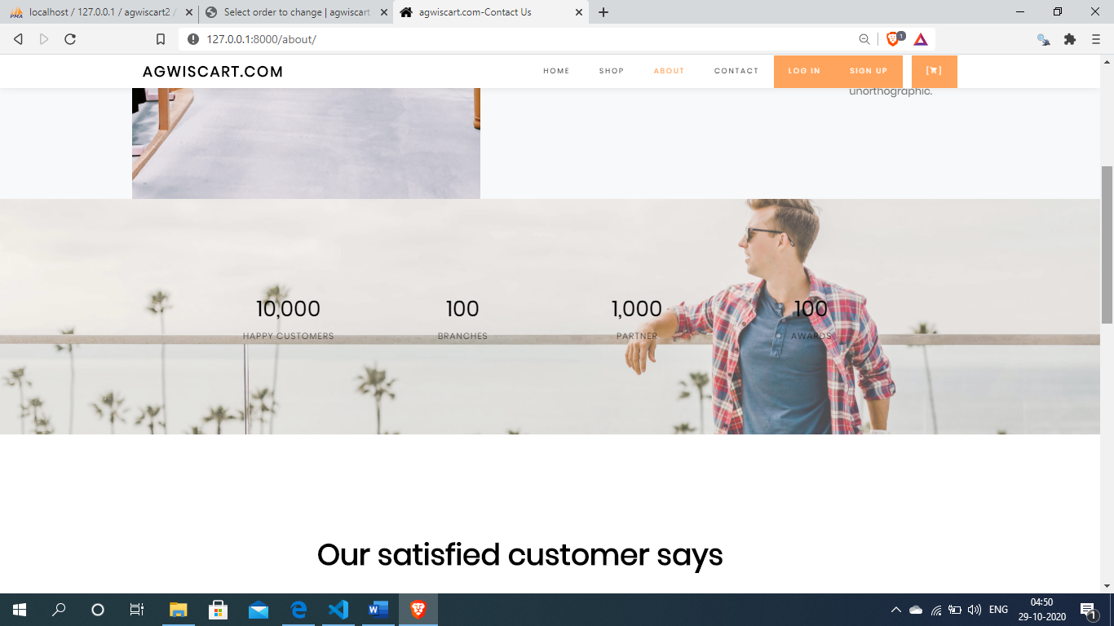

**Contact page:-**

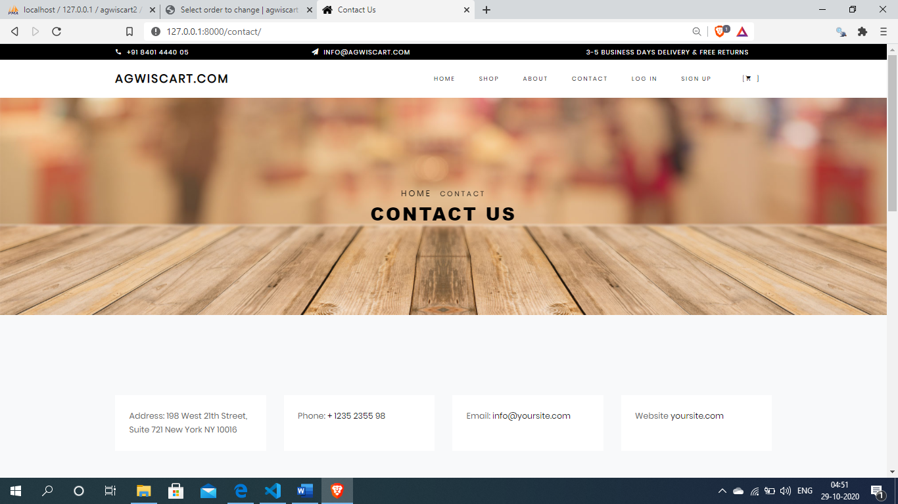

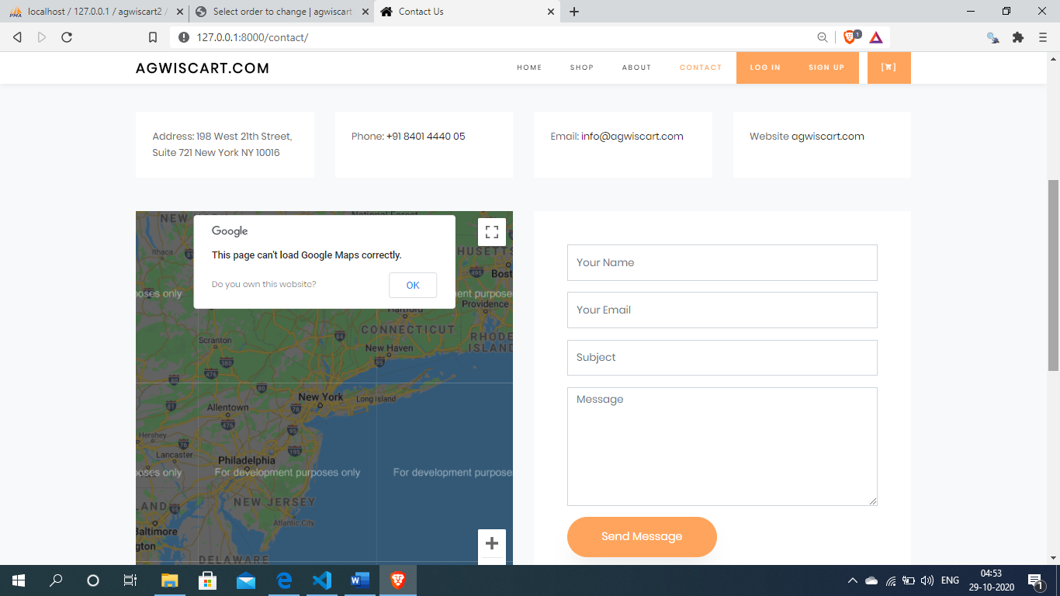

**User log in page:-**

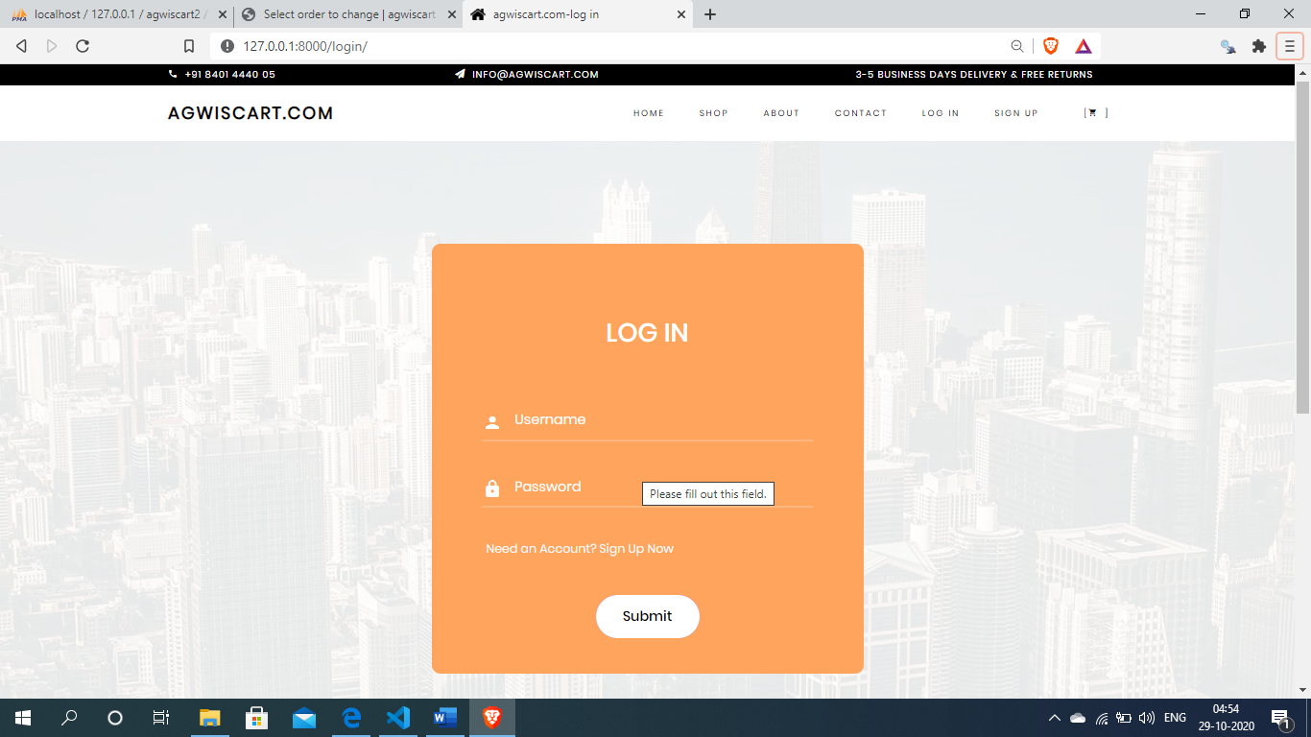

**User sign up page :-**

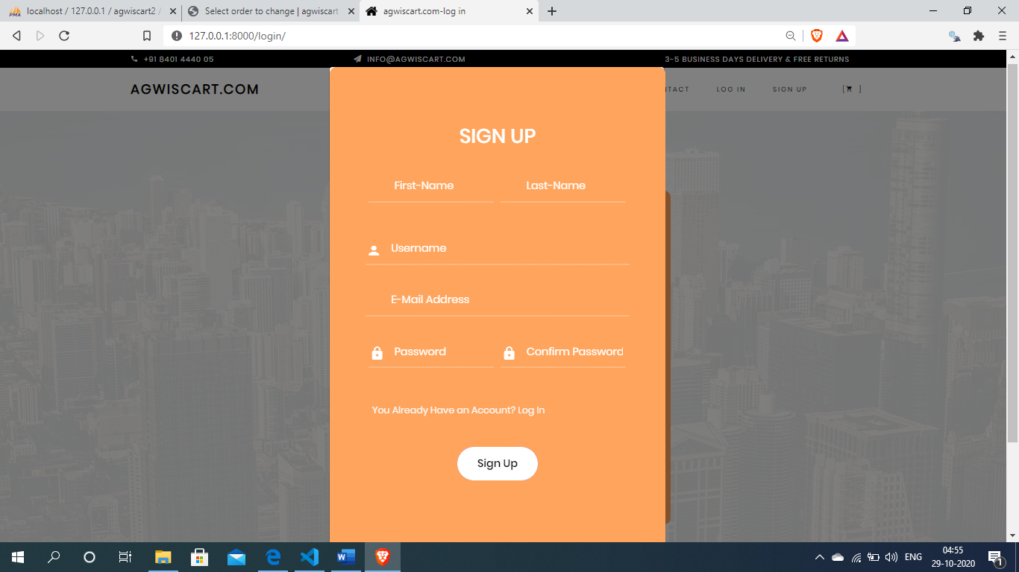

**Shopping cart page:-**

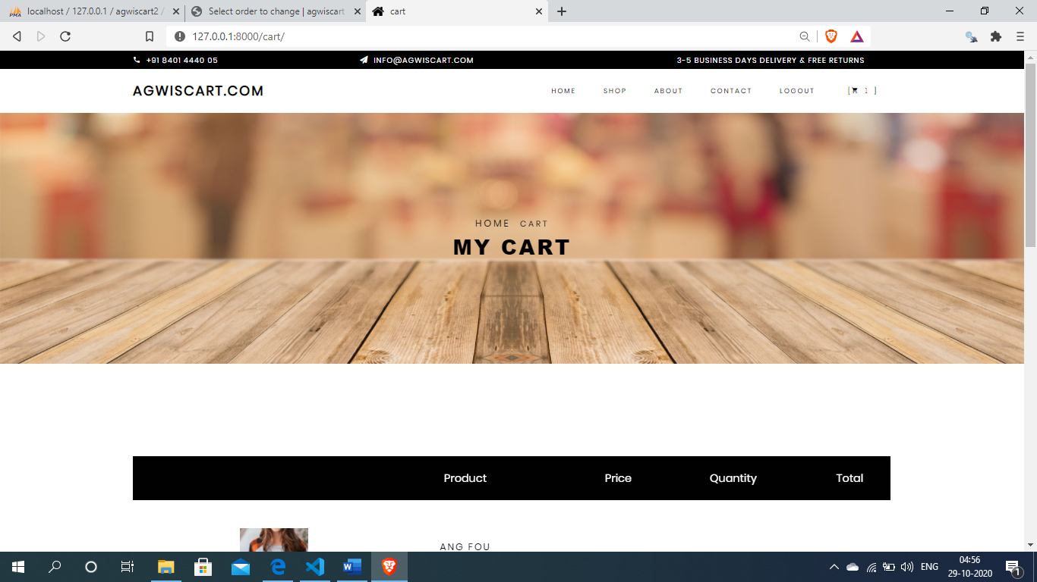

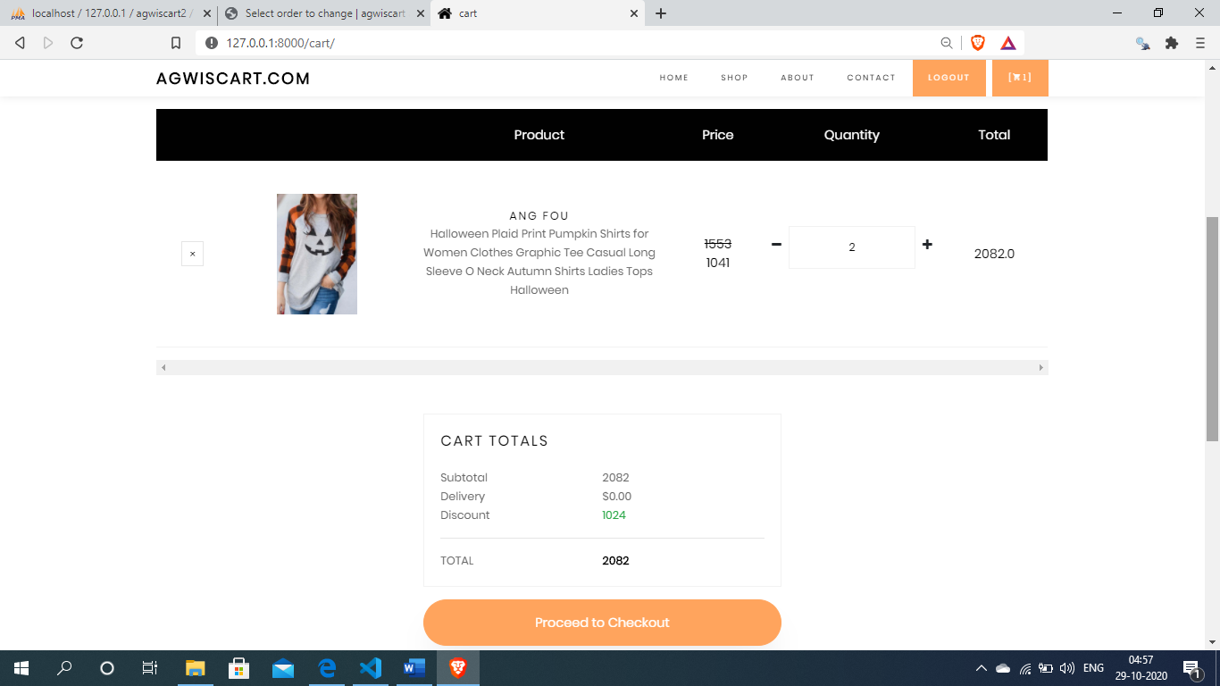

**User checkout page:-**

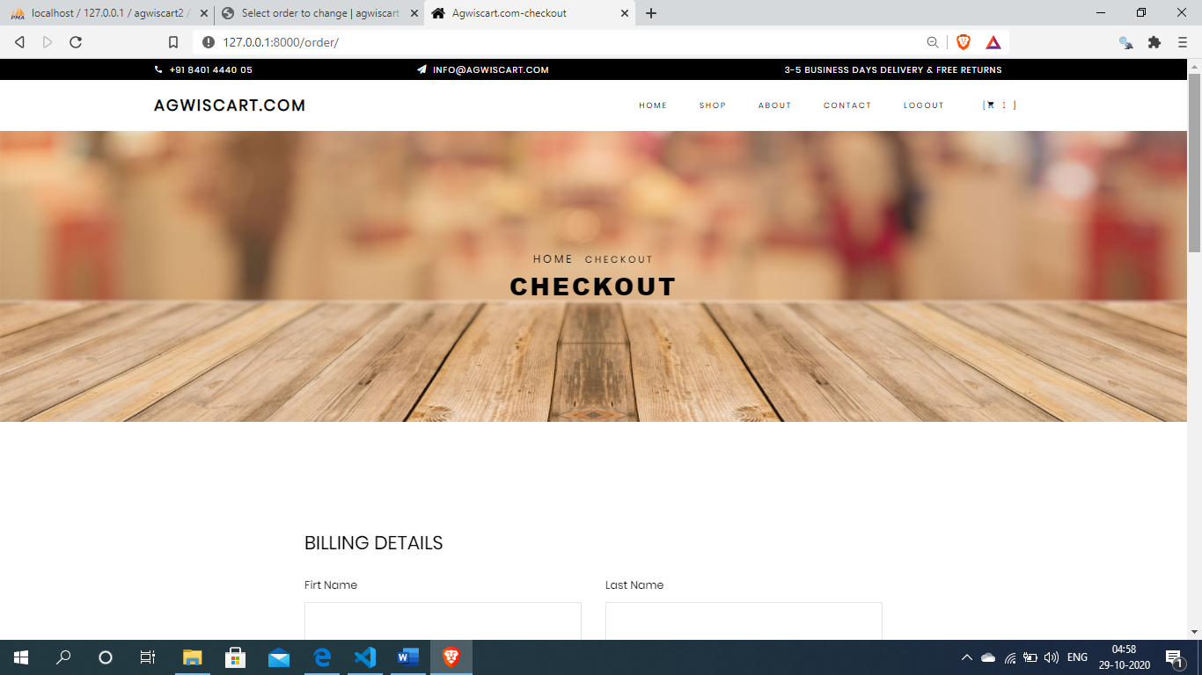

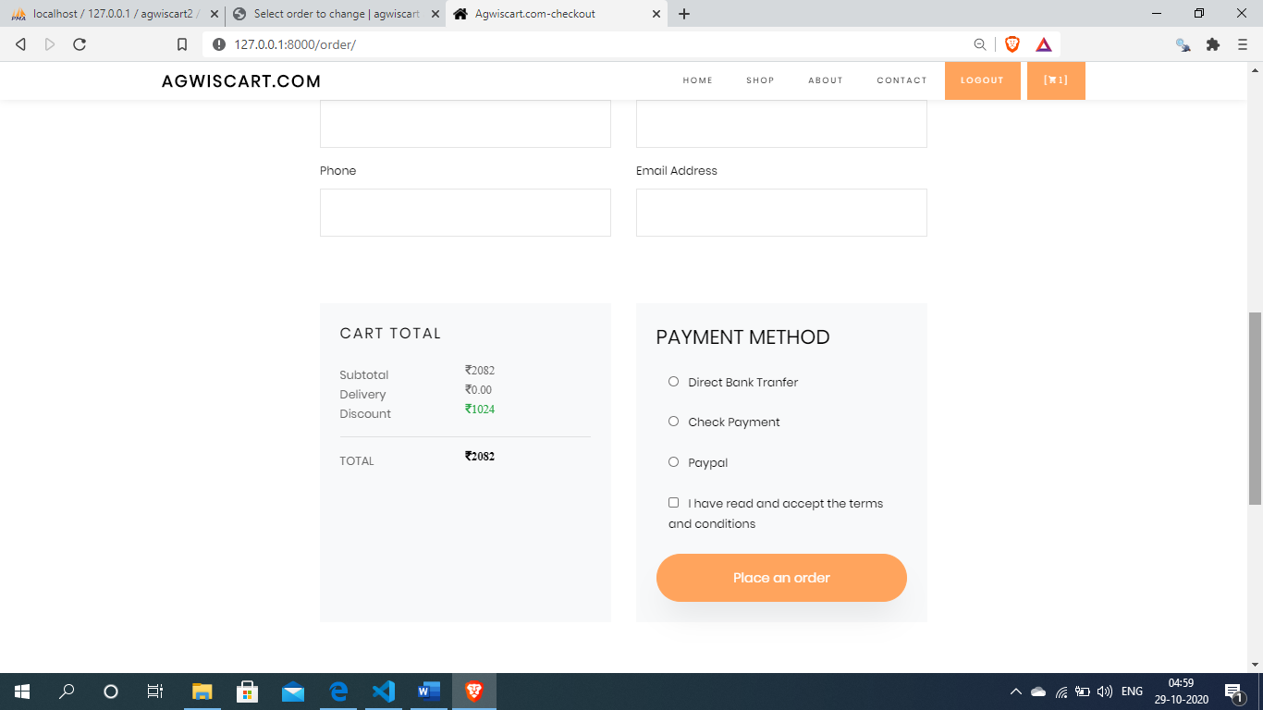

**Payments page:-**

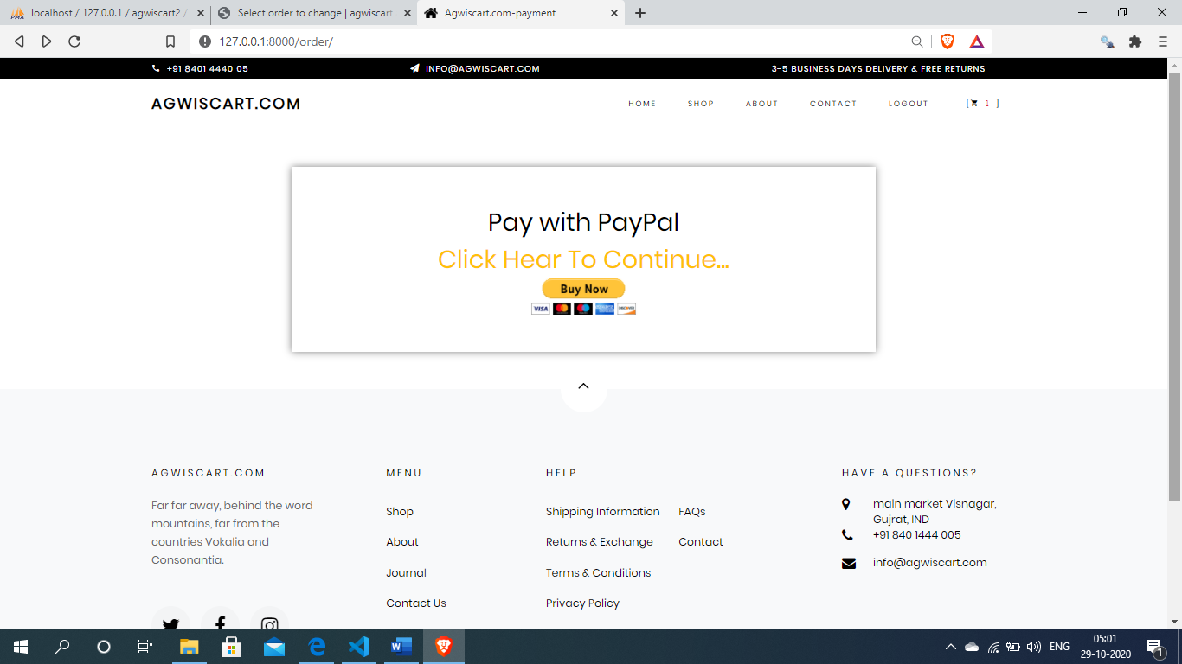

**After click the buy now button open payments gateway(paypal)**

**For pay the bills**

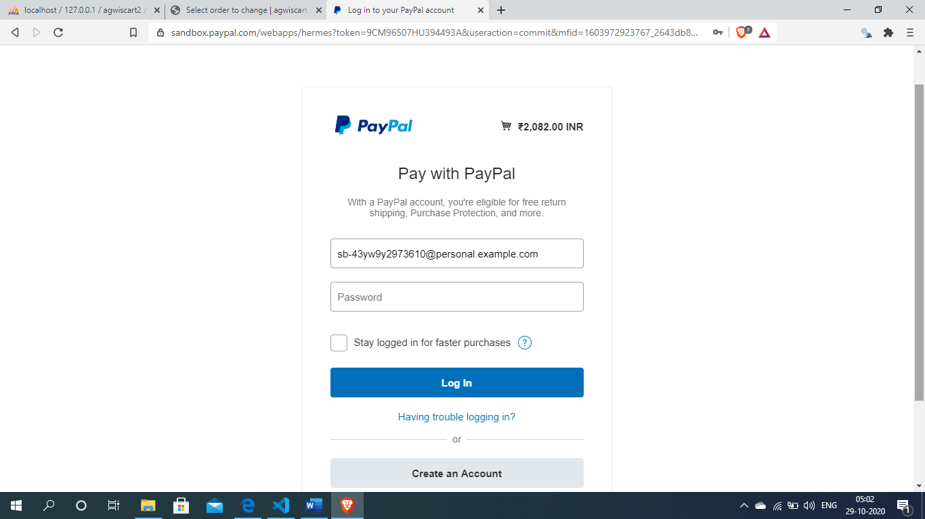

**7.TESTING & RESULT**

**7.1 Introduction**

**TESTING :-**

Software Testing has a dual function it is used to establish the presence of defects in program and it is used to help judge whether or not the program is usable in practice. Thus software testing is used for validation and verification, which ensure that software conforms to its specifications and meets the need of the software customer.

We have resorted Alpha testing, which usually comes in after the basic design of the program has been completed. The project scientist will look over the program and the suggestions and ideas to improve or to correct the design. They also report and give ideas to get rid of around any major problems. There is bound to be a number of bugs after a problem have been created.

**7.2 Test Cases**

**Admin Login Form :-**

|  |  |  |  |
| --- | --- | --- | --- |
| SI NO. | Test case | Expected Result | Test Result |
| 1 | Enter valid name and password & click on login button | Display main window | Success |
| 2 | Enter invalid name and password & click on login button | Does not display main window and show the error | Success |

